Instructions to submit your 4UR request for Registration to Registrar’s Office

Go to https://rpi-registrar.zendesk.com/hc/en-us

- Click Sign In at top right, Sign in using your RPI Email Address
- Click Submit a request at top right
- In the CC box, Enter the email address of your department URP Coordinator.
- Select Yes or No to question Are you a current student, faculty, staff, alumni or previously enrolled student Yes/No (select one)?

- Enter your RIN #. If you do not know the RIN (it can be found on your Campus Card). **Please do not enter your Social Security Number**

- Enter your First and Last Name

- Enter Subject – please enter the Following subject in the box

- Under Registrar Categories select:
Others not listed above
- Add Description * Replace the words written in RED with the information described *

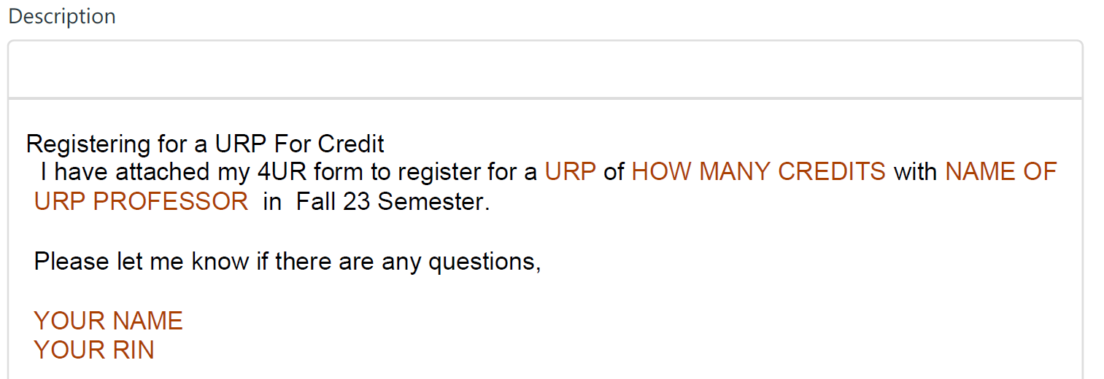

- Under Attachments, click Add file, and attach your signed 4UR form.

- Then click SUBMIT button at the bottom of the page

